User experience/Functional testing comments

- Poor choice of words/word casing

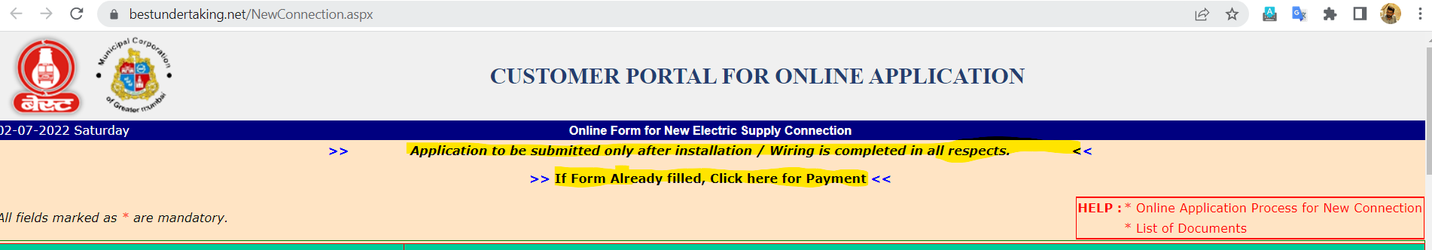

- Inappropriate positioning of redirection links…for example, the payment link in the above screenshot is most likely to be missed by the user and it will be better to be positioned at the end of the form as a button which will navigate the user to the next step

- The double arrows which are trying to highlight the corresponding links are not aesthetically matching for the interface of the application.

- There are no placeholders/suggestions on the format to be used for input to be entered for any of the fields. This will cause a confusion in the mind of user

- A dropdown is more aesthetically pleasing than radiobuttons when there are more than 3 to 4 choices to be displayed

- Inappropriate color scheme is used.

- Incorrect positioning of the below table 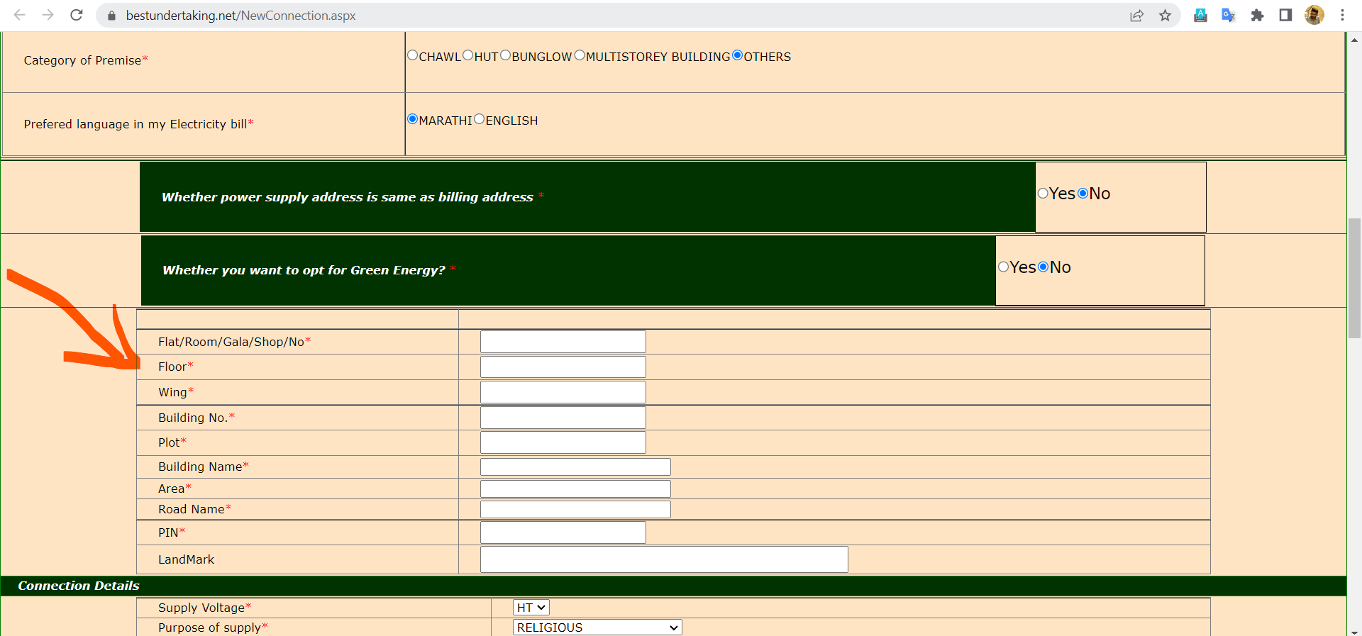

Since the table is related to the choice for ‘Whether power supply address is same as billing address *’ it should be displayed below that section instead of the green energy choice section.

- Incorrect/duplicate positioning of terms and conditions message/the terms and conditions document is not visible
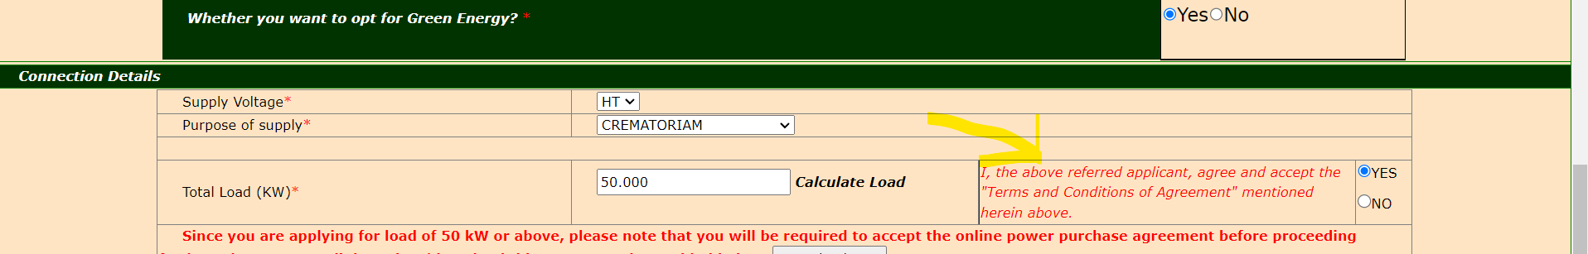

- File format and size not mentioned, as well as user is not getting any validation upon uploading incorrect file types…say .jar files, .class files and so on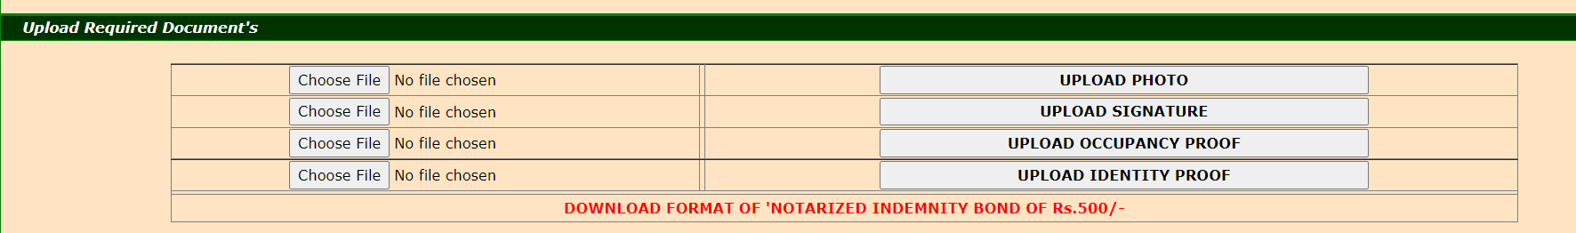

- On uploading valid file(under the assumption that jpeg/png is the expected format) the uploaded data is not reflecting in the below segments
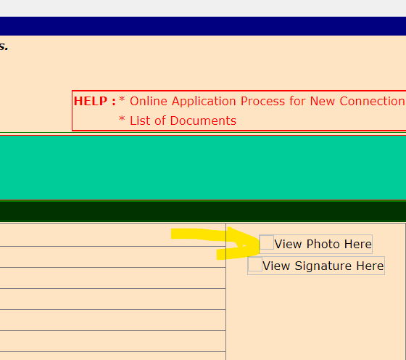

- On clicking validate button for otp, the uploaded documents are removed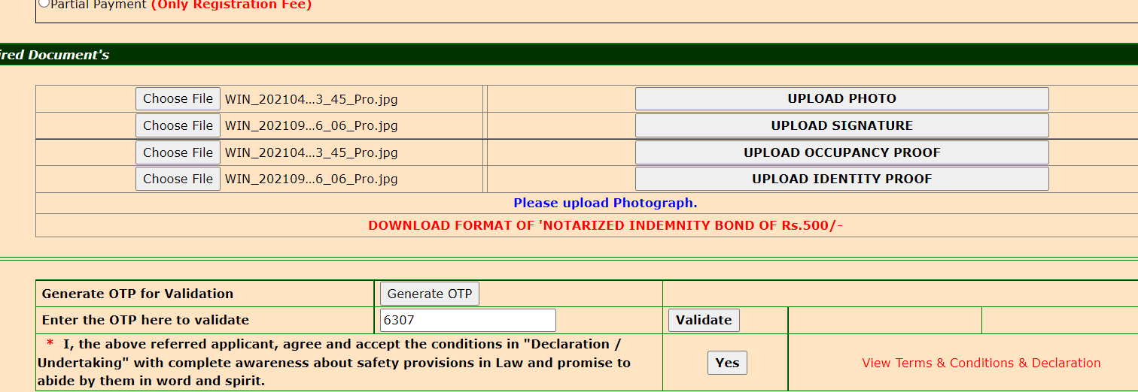

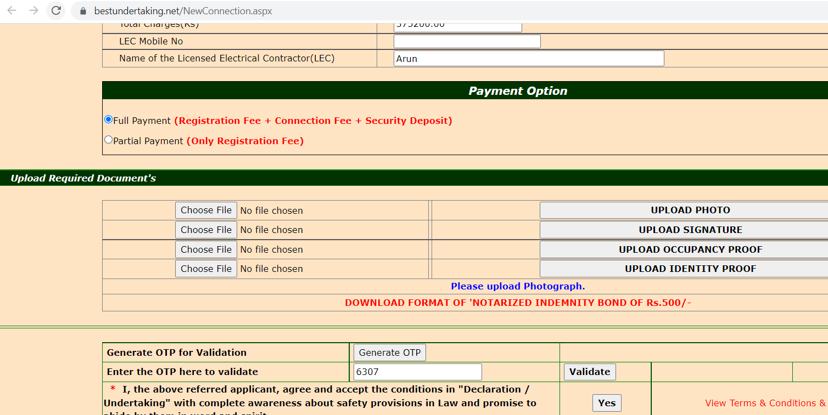

- There is no success/failure message or redirections of any sort upon clicking submit

- Inappropriate positioning of guide document which will be easily missed by the user